Chain of Resp  
  
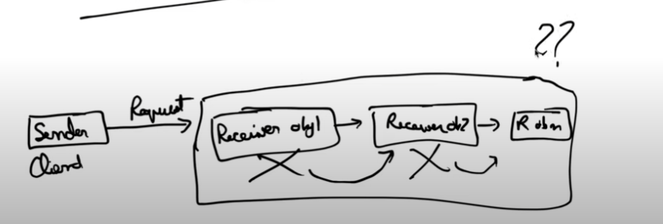  
  
This is used when a request is sent and we don’t know which receiver will full fill this request

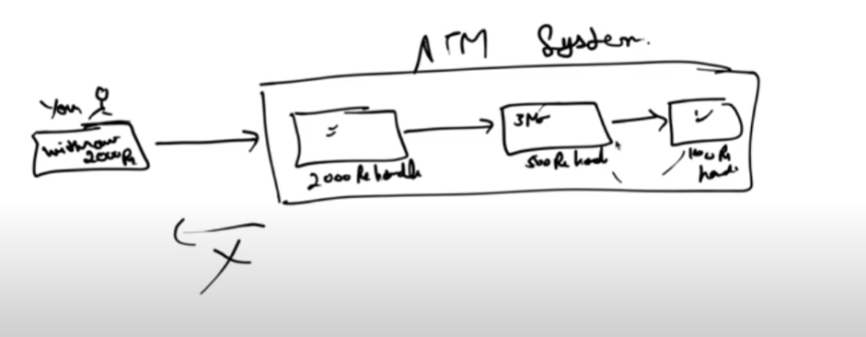

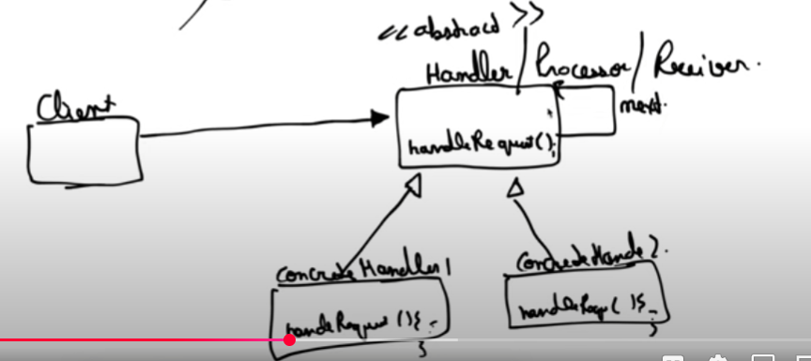  
  
If one handler cannot process the incoming request the request would go to the next handler.

